S1739768

DAH Checkpoint 4: Input/Output and I2C BUS

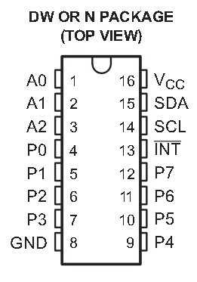***1. Explain the purpose of the SDA, SCL and A0, A1, A2 connections to the PCF8574AN chip***

* SDA pin is the serial data line, connected to VCC through pullup resistor, and it carries data between devices
* SCL is the serial clock line, connected to VCC through another pullup resistor, and it ensures the sending and receiving of data is synchronised
* A0, A1 and A2 are address inputs which are used to identify the device where commands should be sent, so up to 8 devices, addressed 000 to 111 (A2 A1 A0), can share the same SDA and SCL lines but only the intended address acts on a command being sent

***2. If you were to connect the A0 pin to +3.3 V instead of ground, how would you modify your code?***

The full 7-bit address is made up of 0111 followed by what was connected to A0-2. A0-2 were all connected to ground, so the address was 0111000 which is decimal 56 or hexadecimal 38.

So, to setup the chip in code, ‘mcp = PCF8574A(slave=0x38)’ was used.

If instead A0 was set to 3.3V, the address would be 0111001 or hexadecimal 39.

That line of code would have to be changed to ‘mcp = PCF8574A(slave=0x39)’

***3. Why is it necessary to connect the LED to the chip using negative logic, rather than positive (consider the direction of current)?***

From fig.1, the typical current that can flow into each pin P0-3 when set low (‘LOW-level output current’) is ~25 mA. The maximum current that can be drawn out of each pin P0-3 when set high (‘HIGH-level output current’) is ~300 μA or 0.3 mA. Therefore, the pins are much more effective at drawing current in and being set low, so the LEDs were best connected using negative logic, so P0-3 were set low to turn the LEDs on.

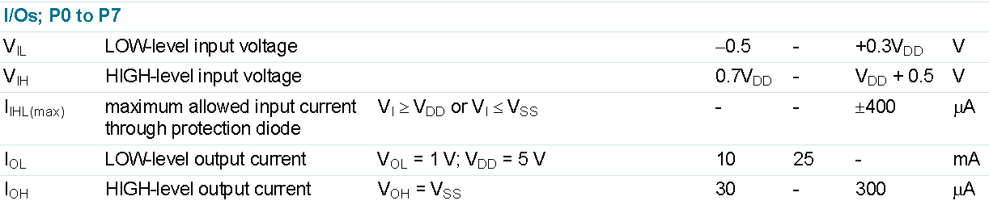fig.1: PCF8574A datasheet ‘static characteristics from http://www.farnell.com/datasheets/1716973.pdf